Multicity DevNet Hackathon Map

**Team and roles:**

|  |  |  |  |
| --- | --- | --- | --- |
| **Problem Owner** | **Fatbardh Tadaj** | **Network Engineer** | **Jörg Niemann** |
| **Developer** | **Jörg Tuttas** | **Time Keeper** | **Vincent Wichmann** |
| **Designer** | **Florian Wrage** | **Note Keeper** | **Simon Baumgarten** |

**Solution description:**

If a teacher or administrator cancels a lesson in there calendar our product will push a fast notification with customized content for individual students. There for our product is connected to a Database, Office365 and Microsoft Flow API with the programming language Python.

**Solution Details:**

|  |  |
| --- | --- |
| **Networking** |  |
| **API**  **Integration** | We use the Office 365 API to listen to a change or cancellation of an outlook calendar event. |
| **User**  **Experience** | Teacher:  Change or cancel events via outlook.  Student:  Receive a push notification, with the information “canceled or change”. Also included is custom learning content. |
| **Data**  **Analytics** | The Office API delivers the name of the appointment. |

**Business Canvas:**

- Schools

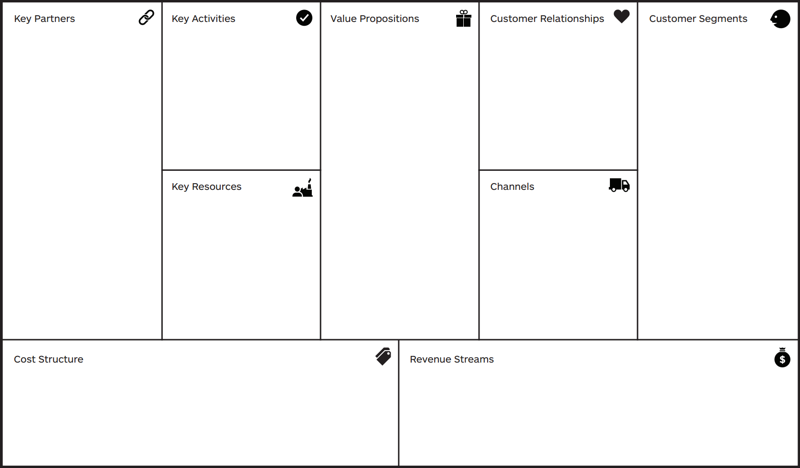

- Advertisment

- Appstore

- Internet

- Low costs

- Most of the applications are free through the internet and school

- School

- Cisco

- Office365

- Youtube

- Google

- Office 365

- Microsoft Flow (API)

- Python

- Internet connection

- Providing learning content

- Fast notification

- Supporting learning

- Help for teachers and students

- Effective studying

- Time saving

- Adoptable to other systems (Office/Companys)

- Support service

- Software updates

**Flowchart:**

|  |
| --- |
|  |

**Logical Network Topology:**

|  |
| --- |
| Router  Router  Internet  Router  Switch  Switch  LaptopServer  SmartphoneSmartphone  Server |

**Sequence Diagram:**

|  |
| --- |
| **Ein Bild, das Karte, Screenshot, Text enthält.  Automatisch generierte Beschreibung** |

**API Integration Map:**

|  |
| --- |
| Office 365 API |